Project Report: Electric Vehicle (EV) Market Analysis
Student Name: Tanishka Sharma
Enrollment Number: en25cs3010968
Tool Used: Tableau Desktop 2026.3
1. Project Objective
To analyze global electric vehicle sales trends, benchmark competitive manufacturer performance, and evaluate year-over-year adoption growth using Tableau.
2. Dataset Summary
Total Records: 200 records
Total Attributes: 37 fields
Key Variables: ⁠Manufacturer⁠, ⁠Annual Sales Units⁠, ⁠Model Year⁠
3. Visualizations Created
Manufacturer Performance (Bar Chart): Compares total annual sales units across manufacturers, showing key market competitors operating near the 3M–4M unit range.
Sales Trend by Model Year (Line Chart): Analyzes market adoption trajectory over time, showcasing cumulative market growth reaching around 80M–90M units.
4. Interactive Dashboard
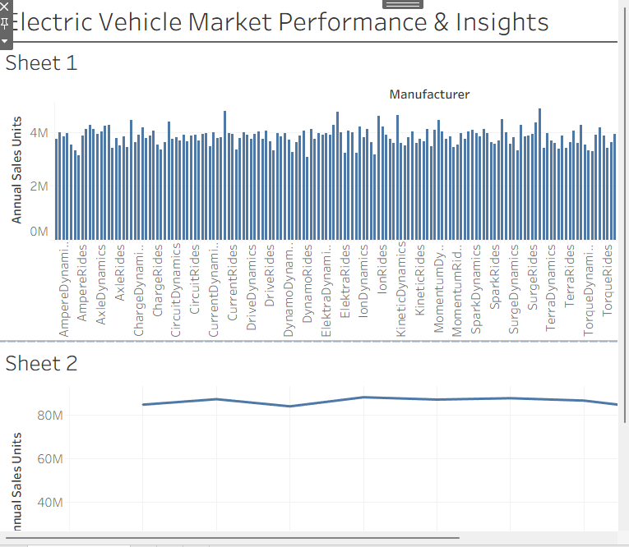
5. Key Insights & Conclusion
Competitive Balance: Sales distribution across major EV brands indicates strong market competition rather than a single dominant player.
Market Growth: Multi-year trendlines reflect steady, positive adoption and expanding consumer demand for electric mobility.
Conclusion: The interactive Tableau dashboard successfully condenses multi-dimensional EV market data into an intuitive visual format for quick decision-making and performance benchmarking.

